**Question:**

Create a table employee. The attributes of employee are empno, empname, place, desig, salary, dept_no, dept_name.

Set empno as primary key and also set 100000 as a default salary of employee

Create a constraint where the dept_no ranges from 1 -10

a.       Display the empno, empname and salary.

b.      Display all records of employee table

c.       Display the details of the employee whose salary is greater than 10000

d.      Increment the salary of ‘officer’ by 1000

e.       Display the name and id of employee whose salary ranges between 10000 and 15000

f.        Display the employee details whose name start with ‘A’

g.      Change the salary of officer to 15000

h.       Add a column district to the table

i.        Delete the column district

j.        Modify the column name desig to designation

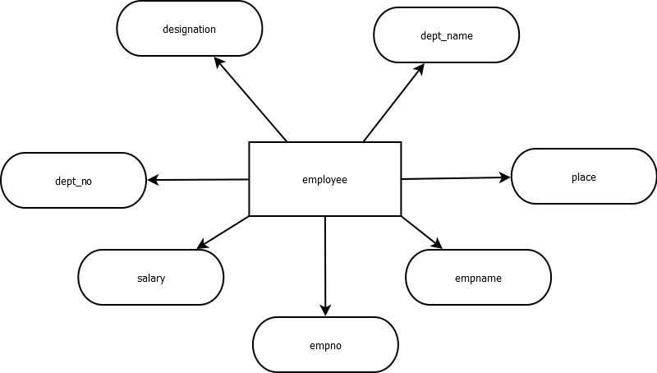

SQL> CREATE TABLE employee (empno INT PRIMARY KEY, empname VARCHAR(20), place VARCHAR(20), desig VARCHAR(20), salary INT DEFAULT 100000, dept_no INT CHECK (dept_no >= 1 AND dept_no <= 10), dept_name VARCHAR(20));

SQL> DESC employee;

Name Null? Type

---------------------------------- ---------- ----------------------------

EMPNO NOT NULL NUMBER(38)

EMPNAME VARCHAR2(20)

PLACE VARCHAR2(20)

DESIG VARCHAR2(20)

SALARY NUMBER(38)

DEPT_NO NUMBER(38)

DEPT_NAME VARCHAR2(20)

**a)**

SQL> SELECT empno, empname, salary FROM employee;

EMPNO EMPNAME SALARY

---------- -------------------- ----------

1 Zameel Hassan 100000

2 Sumayya Maheen 55000

3 Vivek M Nair 48000

4 Albin J 8000

5 Krishnendu K 30000

6 Sravan 15000

7 Prinu V Nair 13000

7 rows selected.

**b)**

SQL> SELECT * FROM employee;

EMPNO EMPNAME PLACE DESIG SALARY DEPT_NO DEPT_NAME

---------- -------------------- -------------------- -------------------- ---------- ---------- --------------------

1 Zameel Hassan Kasaragod CEO 100000 6 CS

2 Sumayya Maheen Kollam CTO 55000 6 CS

3 Vivek M Nair Kottayam COO 48000 6 CS

4 Albin J Idukki MANAGER 8000 6 CS

5 Krishnendu K Alappuzha Developer 30000 6 CS

6 Sravan Alappuzha Intern 15000 6 CS

7 Prinu V Nair Kollam Officer 13000 6 CS

7 rows selected.

**c)**

SQL> SELECT * FROM employee WHERE salary > 10000;

EMPNO EMPNAME PLACE DESIG SALARY DEPT_NO DEPT_NAME

---------- -------------------- -------------------- -------------------- ---------- ---------- --------------------

1 Zameel Hassan Kasaragod CEO 100000 6 CS

2 Sumayya Maheen Kollam CTO 55000 6 CS

3 Vivek M Nair Kottayam COO 48000 6 CS

5 Krishnendu K Alappuzha Developer 30000 6 CS

6 Sravan Alappuzha Intern 15000 6 CS

7 Prinu V Nair Kollam Officer 13000 6 CS

6 rows selected.

**d)**

SQL> UPDATE employee SET salary=salary+1000 WHERE desig='Officer';

1 row updated.

**e)**

SQL> SELECT empname, empno FROM employee WHERE salary>=10000 AND salary<=15000;

EMPNAME EMPNO

-------------------- ----------

Sravan 6

Prinu V Nair 7

**f)**

SQL> SELECT * FROM employee WHERE empname LIKE 'A%';

EMPNO EMPNAME PLACE DESIG SALARY DEPT_NO DEPT_NAME

---------- -------------------- -------------------- -------------------- ---------- ---------- --------------------

4 Albin J Idukki MANAGER 8000 6 CS

**g)**

SQL> UPDATE employee SET salary=15000 WHERE desig='Officer';

1 row updated.

**h)**

SQL> ALTER TABLE employee ADD district VARCHAR(20);

Table altered.

**i)**

SQL> ALTER TABLE employee DROP COLUMN district;

Table altered.

**j)**

SQL> ALTER TABLE employee RENAME COLUMN desig TO designation;

Table altered.

**FINAL TABLE**:

EMPNO EMPNAME PLACE DESIGNATION SALARY DEPT_NO DEPT_NAME

---------- -------------------- -------------------- -------------------- ---------- ---------- --------------------

1 Zameel Hassan Kasaragod CEO 100000 6 CS

2 Sumayya Maheen Kollam CTO 55000 6 CS

3 Vivek M Nair Kottayam COO 48000 6 CS

4 Albin J Idukki MANAGER 8000 6 CS

5 Krishnendu K Alappuzha Developer 30000 6 CS

6 Sravan Alappuzha Intern 15000 6 CS

7 Prinu V Nair Kollam Officer 15000 6 CS